Task 7 - Sales Summary Using SQLite and Python

Objective:
Use SQL inside Python to pull simple sales information (such as total quantity sold and total revenue) from a SQLite database, and display it using print statements and a basic bar chart.

Tools Used:
• Python (SQLite, pandas, matplotlib)
• SQLite database (sales_data.db)
• Visual Studio Code / Jupyter Notebook

Steps Performed--

1. Created SQLite Database:
A SQLite database file named 'sales_data.db' was created using Python. A 'sales' table was created with columns:
• product_name
• quantity
• price

2. Inserted Sales Data:
Inserted data into the sales table such as iPhone 14, Samsung S23, Dell XPS 13, HP Pavilion, and AirPods Pro.

3. SQL Query Execution:
A SQL query was executed using pandas to calculate total quantity and total revenue for each product:
SELECT product_name, SUM(quantity) AS total_quantity, SUM(quantity * price) AS total_revenue FROM sales GROUP BY product_name;

4. Visualization:
A bar chart was created using matplotlib to visualize revenue per product. This successfully displayed the final output.

Step 1 – Create SQLite Database
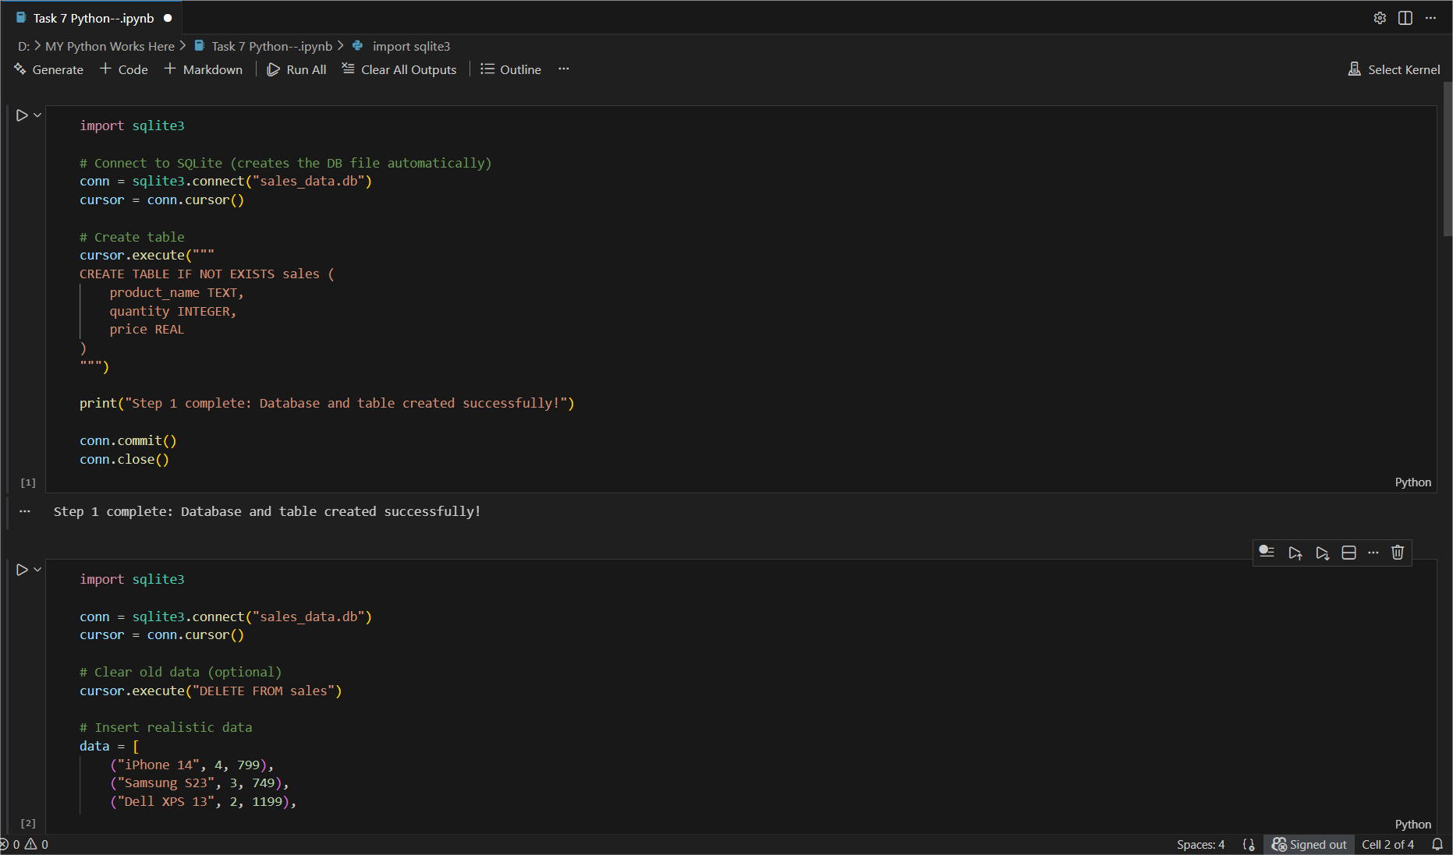

Step 2 – Insert Sales Data

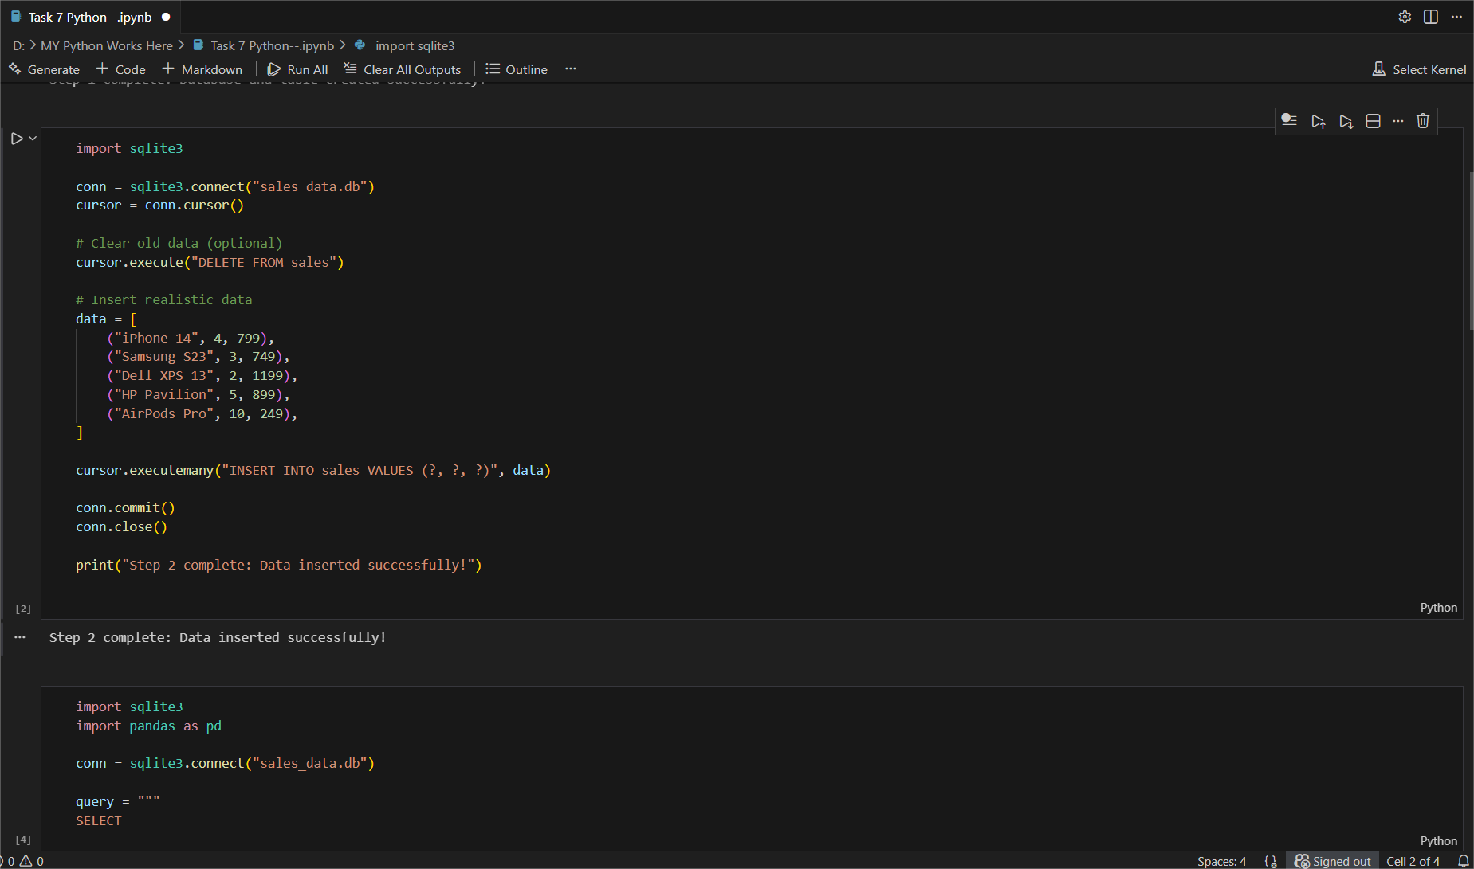

Step 3 – Query Sales Summary
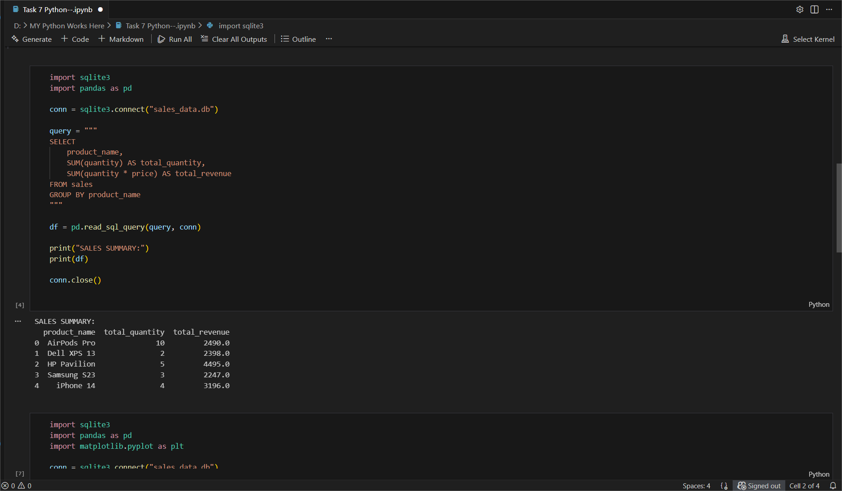

Step 4 – Visualize Revenue by Product
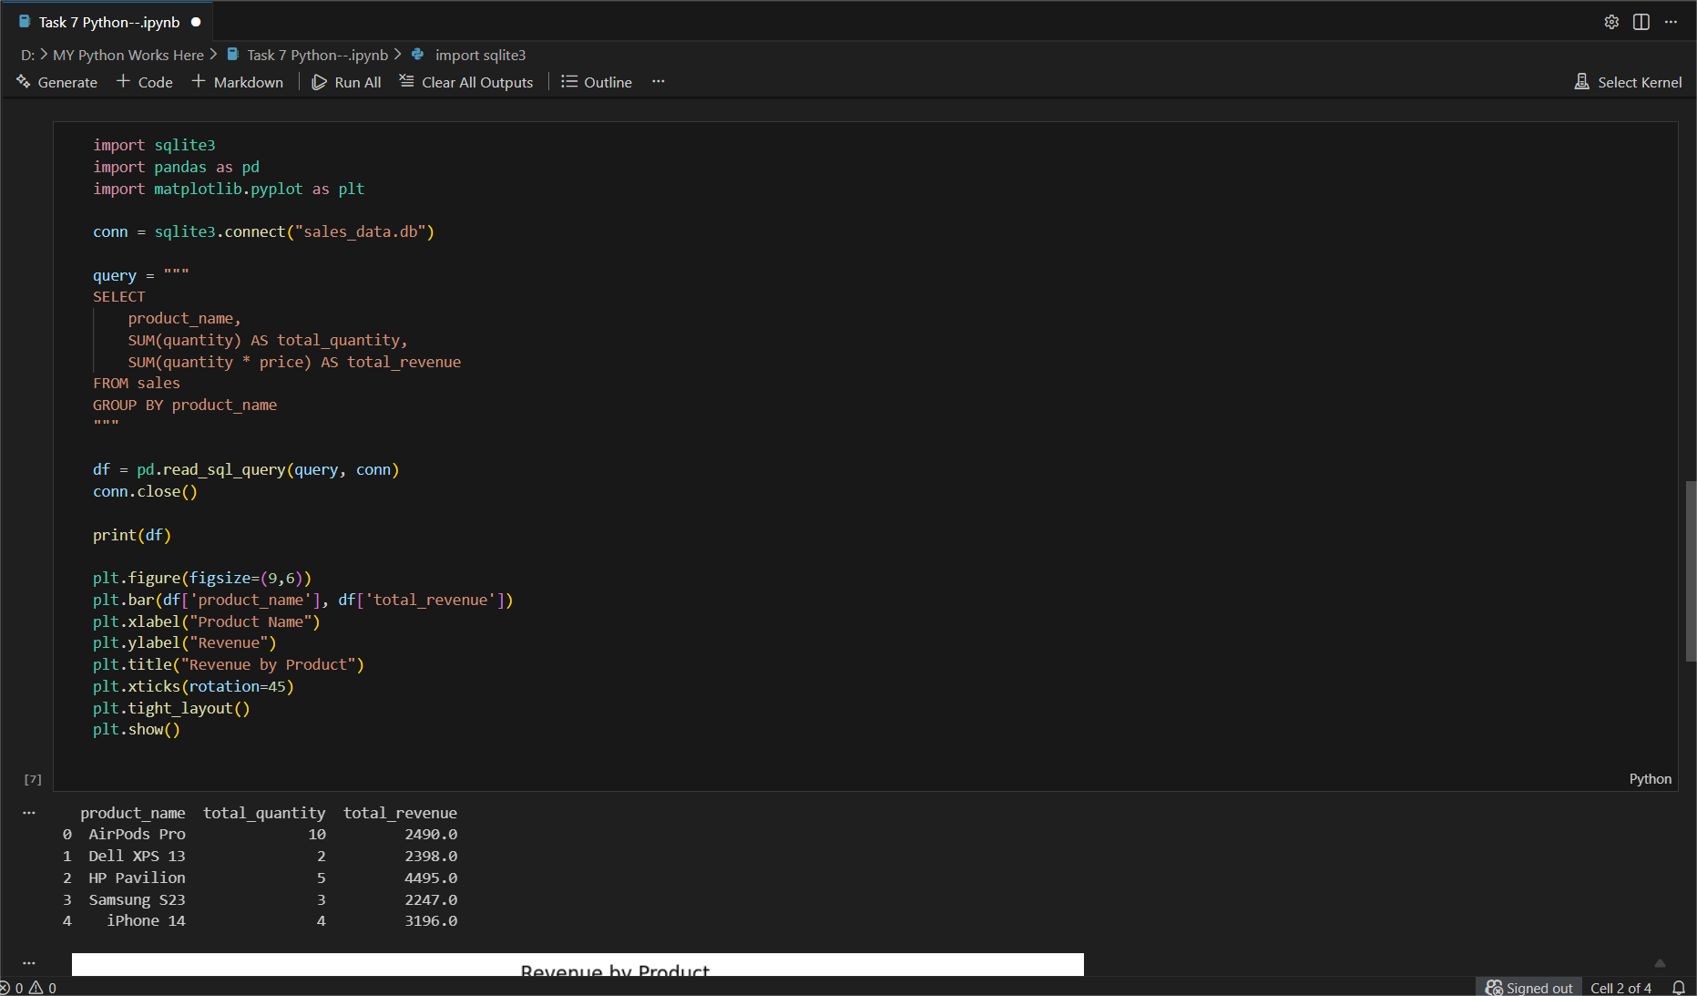
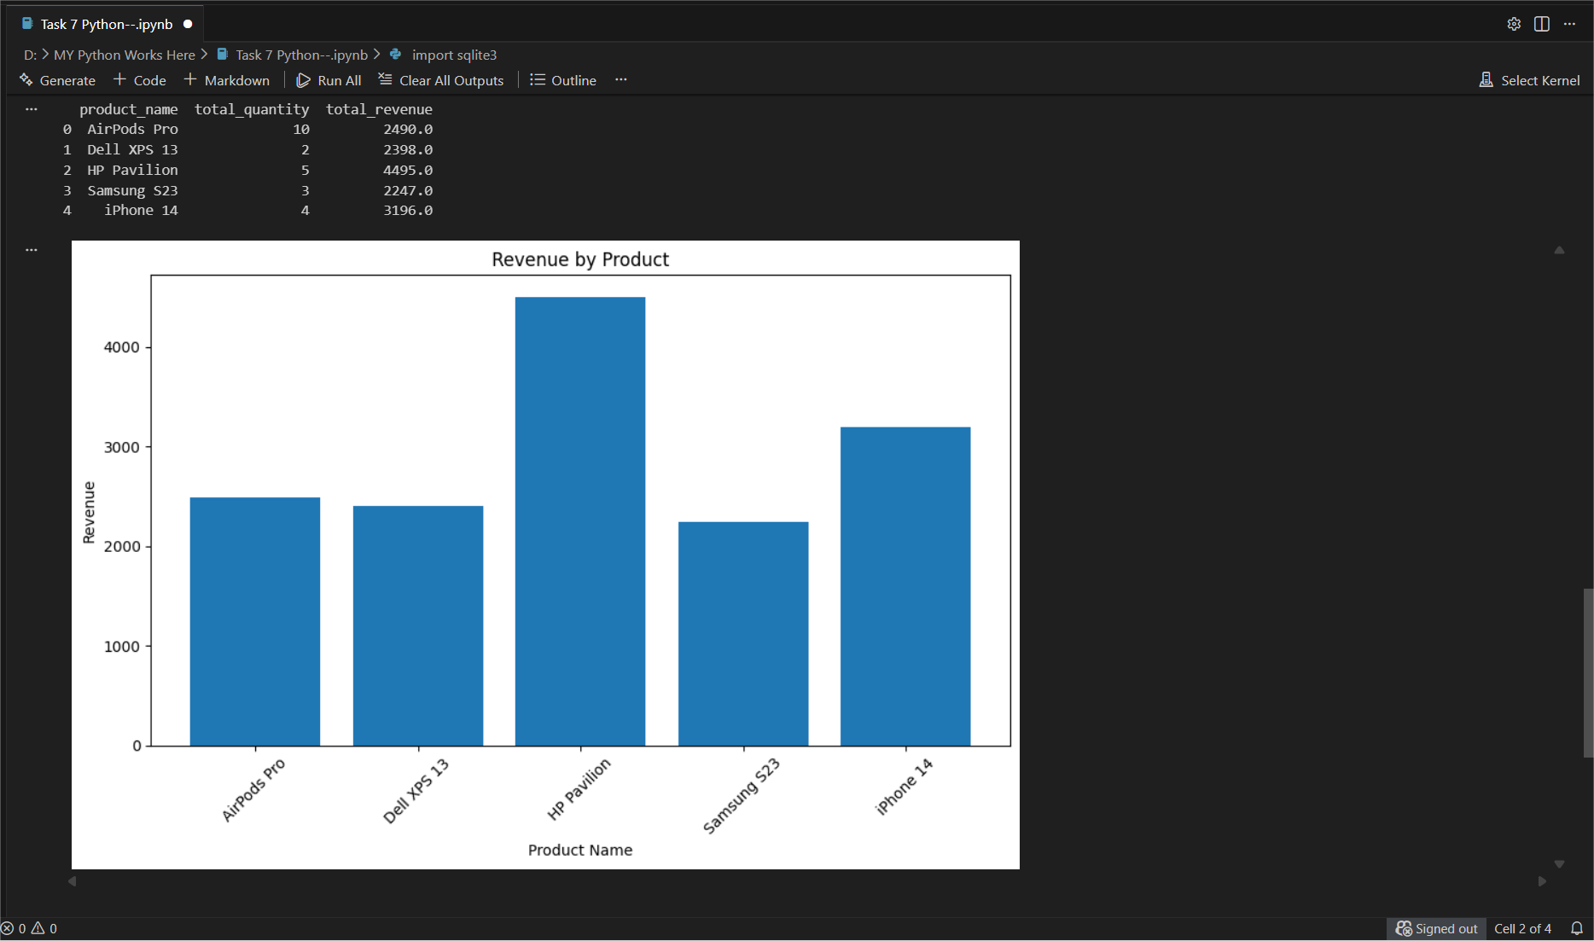

Conclusion:
Task 7 was successfully completed. A SQLite database was created, sales data was inserted, and SQL queries were used to calculate total quantity and revenue for each product. The results were displayed using pandas and visualized with a bar chart in Python. This task helped understand how databases and Python work together for basic data analysis.

